Nature of Science

- Science assumes that the world can be ________________, given enough ___________

and _______________________.

- All ideas in science are constantly being _______________________________________

_______________________________________________________________________.

- Define hypothesis -

- Define theory -

- Scientific discoveries must be reproducible. What does this mean?

- Define pseudoscience –

- Spontaneous generation is an example of pseudoscience. Give two reasons why.

- What was the goal of alchemy? Why did the study of chemistry advance so little during this time?

- Why is the study of astrology not really considered scientific?

Scientific Method

- All scientific studies follow the same sequence of steps, called the _________________

____________________.

- Fill in each of the parts of the scientific method from the diagram below.

- Fill in the steps of the scientific method.

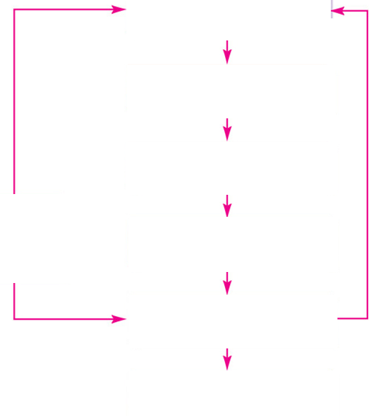
- Define observation –

  - What observation did Dr. Jenner make when studying smallpox?

- Define hypothesis –

  - Can hypotheses be proven false?

  - What was Dr. Jenner’s hypothesis?

- Define experiment –

  - A controlled experiment will attempt to test a _____________ ________________.

- There are two groups in a controlled experiment. Define each:

  - Experimental Group:

  - Control Group:

- Describe the control and experimental groups in Dr. Jenner’s experiment.

- Define conclusion -

- What is the purpose of communicating the results of an experiment?

  - What happened when Dr. Jenner communicated his results to the Royal Society?

Error and Bias

- Define probability -

  - How is the issue of probability countered?

  - What did Dr. Jenner do to answer his critics?

- What does it mean to conduct a natural experiment?

  - Give an advantage of this kind of experiment.

  - Give a disadvantage of this kind of experiment.

- Define bias -

- Two types of experimental design exist to combat bias. Describe each one.

  - Blind:

  - Double-Blind:

- Scientific fraud is always detected, eventually, due to the _______________________ and

____________________.

  - What damage is caused by scientific fraud?

- The MMR Vaccine and Autism study published by Dr. Wakefield is considered an example of scientific fraud. What effects were caused worldwide by it?

